Everything Enterprise Default

The catalog for libraries in the Winnefox Library System is located at http://wlso.ent.sirsi.net

When you first go to the catalog, you will be prompted to select a library. 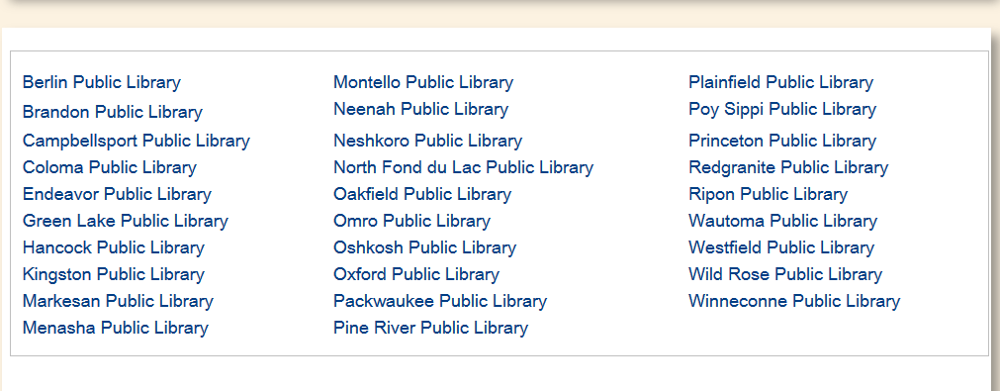
This library will be used to determine which library’s items you see first on the lists of libraries who own items.

After choosing a library, you will be taken to the front page of the catalog:
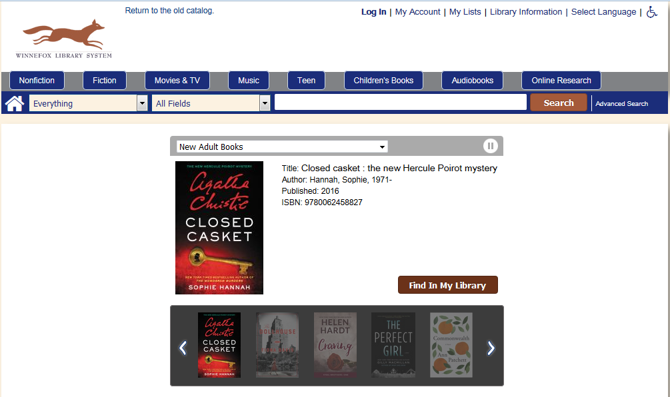

From here, you may log into your account by using the Log In link on the top-right bar:
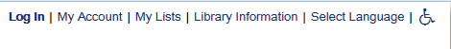
On this bar, you can also access My Account, My Lists, and see basic Library Information about your library. Clicking on the Select Language link will translate many of the labels and interface into Spanish. For ADA compatibility, you can use Accessibility Mode by clicking on the icon of a wheelchair.
(For more information on My Account and My Lists, please follow the links to additional documentation.)

On this page, you can enter search terms to search the catalog (you don’t need to log in first):
By default, the catalog searches using your search terms as a keyword search. If you would like to search for a specific title or author, click on the dropdown box on the “All Fields”:

Click on the field you would like to search by: Author, Title, Series, Subject, or ISBN.
If you choose to search for “Keyword in Author headings” or “Keyword in Subject Headings”, instead of searching the catalog directly, your term will be used to search the list of author and subject headings of items.

At any point in your searches, you can click the house icon on this search bar and it will bring you back to this page.
For more information about searching, please see the Searching In Enterprise document.

Beneath the search bar is a display of new books.
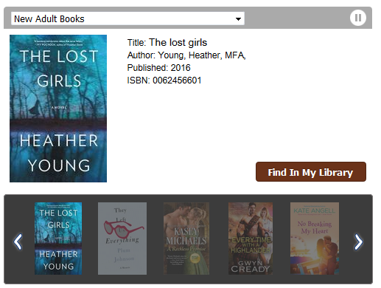
These books are both fiction and nonfiction books that at least one library within the system added to their collections in the last week. If you see one that interests you, you can click the “Find in My Library” button to bring up more details about the book, including which library owns it and if it is available.

You can use the right and left arrows on either side of the list of books to change the page of the booklist, or it will automatically scroll through the books.

If you would like to pause the books as they scroll through, click the “pause” button on the right-hand side of the header:
To resume the automatic scroll-through, click the button again.

By default, the booklist that appears on this front page is the list of new Adult (that is, not children’s or teen’s) books. You can change which list you would like to see by clicking on the dropdown box of “New Adult Books” and clicking the list you are interested in viewing.
Available lists to choose are New DVDs (a library added the DVD or Blu-Ray item in the last week), new Kids materials, New Large Print/Type materials, and the New York Times Best Seller list for the week.

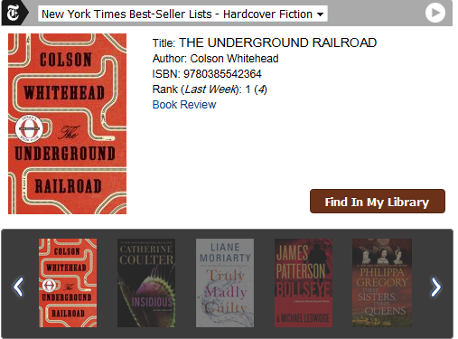

Above the search bar are buttons containing quick searches for previously defined categories.
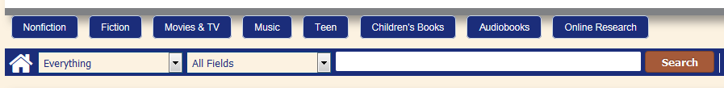

Mouse over the general category you are interested in to see the list of options of pre-defined searches. For example, to view searches for Nonfiction categories, mouse over the “Nonfiction” button:

Click on the category you are interested in searching for. For example, to search for Civil War books, click on the Civil War category.

The search will automatically be performed, and you will be taken to the results:
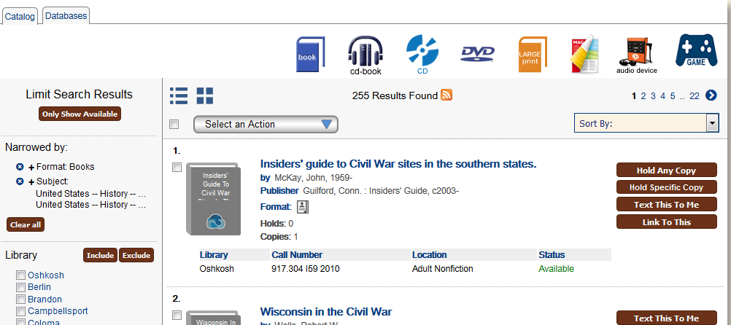
It is important to note that these quick searches often have facets built into them; trying to further limit the search results with facets might not have the expected results, especially when trying to narrow by format of material. (For more information about facets, please see the Filtering Searches In Enterprise document.)

If you would like eBooks, you can mouse over the “eBooks” tab on the button’s expanded menu box, and the searches will change to look for eBooks only.

eAudiobooks can be searched for under the “Audiobooks” button, along with books on CD and Playaways.
For more information about finding and downloading eBooks and eAudiobooks in the catalog, please see the eBooks and eAudiobooks in Enterprise document.

The Online Research button contains links to your library’s electronic resources.
For example, if you click on “Genealogy”, you will be directed to your library’s page of Genealogy resources:
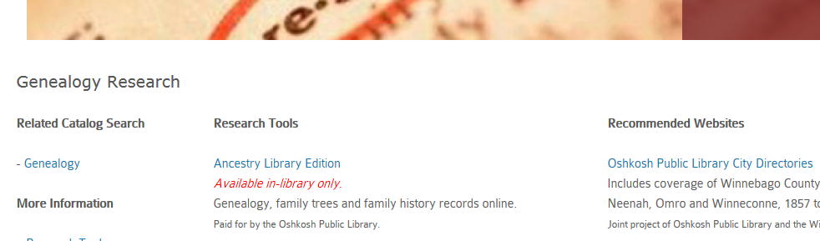

More information on using the new catalog can be found can be found on the Catalog Tutorials page of the extranet.

